ChargingBuddy – A Secured Charging Station Using Internet Of Things
Sagar Ambilpure*, Uzair Chhapra*, Aditya Chavan*, Prof. Dnyaneshwar P. Kapse**
*Authors, **Project Guide

¹ University of Mumbai, Mumbai Maharashtra, India
² University of Mumbai, Mumbai Maharashtra, India
³ University of Mumbai, Mumbai Maharashtra, India
⁴ University of Mumbai, Mumbai Maharashtra, India
sagarambilpure@gmail.com
uzairchhapra@gmail.com
adityachavan198@gmail.com
dnyaneshwar.kapse@mctrgit.ac.in
Abstract. Currently, when a user’s cell phone runs out of battery and there is no charging outlet nearby there is very little or nothing that the user can do about it. Even if a charging outlet is available nearby one would have to stay close to the charging outlet until the phone is charged. Our system would provide such users with a solution that would enable them to do other things while the cell phone is being charged without worrying about the safety of their phones. Our charging stations would be located at various public places which would be available for all the registered users. These Secured Charging Stations would be like vending machines i.e. fully automated using the Internet of Things (IoT). These charging stations, when placed in stores, would attract more customers and increase their dwell time which would consequently increase sales. The mobile phone is our means to remain connected. While the phones have progressively got more powerful processors and large touch screen interfaces, their power requirement has increased correspondingly. Unfortunately, battery technology has not been growing at a comparable pace. Hence, there is a need to frequently charge the batteries. While traveling, people face a common problem of charging electronic appliances. Most of the cell phone users have experienced having their cell phones run out of battery when they are not near a charging outlet. This project is an excellent example of Ubiquitous computing that uses Cloud computing for solving a widespread problem.
Keywords: Internet of Things (IoT), Secured Charging Station, Ubiquitous computing, Cloud computing.
- Introduction
This project is basically about developing a mobile charging station. In the contemporary world, mobile phones have become an indispensable tool for mankind. Smartphones of today are portable computers. With the rise in speed, power, and capability in mobile phones, there has been an equal and opposite effect on its power consumption. Even though the processors today strive to be power efficient, yet they do consume a lot of power in the first place.

No doubt, battery technologies today have also improved over the years. But this improvement is nowhere near in proportion to the demands of the power-hungry microprocessors used in mobile phones. What this means is that phones, say around 10 years back, weren’t smart enough to do many tasks that they today. But what this also means is that those phones used to last for days if not weeks on a single charge. The problem of on the go charging for mobile phones never really existed back then. It is only in the recent past this problem has started to take the center-stage.

The solution to this battery problem in smartphones of today has not been completely found. Smartphone manufacturers have tried solutions like fitting the largest possible batteries in the phones, optimizing their software, and various other methods. In recent years, faster-charging methods have also been implemented in mobile phones so that they safely draw large amounts of power to charge quickly. All such solutions have undoubtedly been helpful, but the fact of the matter is that even after all these methods, tons of smartphone users have to be on-the-go all the time and do not get access to charging their mobile phones. Such people generally carry mobile power banks.

The problem with power banks is that they are cumbersome to carry and that they also need to be charged again and again for storing the extra juice. While this is a reasonable enough solution to the charging problem, but it is quite a cumbersome one. The basic idea of our project is to provide public charging stations with a locker mechanism for minor power top-ups at major public places.
- Literature Review
Mobile charging stations are not new to the people. In fact, they have been present for quite a while now. The reason they are not heard of enough or appreciated enough is that, in its existing form, it is quite cumbersome to use.

  - Survey of Existing System
There are various mobile charging stations that have already been developed. These stations use wired technology within them to handle or secure mobile phones. Most charging stations are not secured. The owner has to stand near their mobile phones to make sure nobody else runs away with it. Another drawback of the current form of the mobile charging station is the fact that such stations work in an entirely offline manner.
The mobile battery charger starts charging a mobile connected to it when a coin is inserted at the coin insertion slot at the input stage. The type of coin and the size will be displayed at the LCD for the user to ensure correct coin insertion. Any other coin, if inserted in the slot will be returned to the refund box. A sensor attached to the coin insertion slot accepts the coin into the battery charging unit and start charging the mobile battery for a specific period controlled by the software of the microcontroller. The sensor is an IR sensor.

The resistance of the sensor decreases when IR (infrared) light falls on it. A good sensor will have near-zero resistance in the presence of light and a very large resistance in the absence of light. When the coin obstructs the IR light falling on a sensor, it sends a pulse to the control unit authorizing the start of charging the mobile battery connected to the device. Two IR sensors are used for positive authentication of the charging process [1].

Coin accepted or rejected is based on the diameter of the coin. This invokes microcontroller along with the LCD interface displays the selection of mobile option if a particular mobile is selected for charging the corresponding routine is activated and charge the mobile for a particular duration of time. When the routine completes, it indicates charge complete message through the LCD. Similarly, the same procedure is followed for charging more than four different mobiles simultaneously.

  - Limitations of Existing System
There are various limitations to the current model of a mobile charging station. Some of them are as follows:
Security: Most current charging stations are open in nature. There are no personalized lockers for a user’s mobile phone to be put in.
Hardwired: The current forms of mobile charging stations are all hardwired. Even those with lockers in them open their locks by passing messages through wires. Wireless communication has never been used in such systems.
- No IoT Device: For seamlessly using the proposed charging station, we believe that IoT has to be incorporated. This is missing in the current systems. The reason for the equipment interface unit is all the electronic home apparatuses are associated with the raspberry pi board which is associated with the Wi-Fi by utilizing the Wi-Fi module. All the electronic machines are worked and controlled through our advanced mobile phone or PC or tablet [2].
- No Cloud Connectivity: The AWS IOT platform acts as the cloud server for exchanging the information between the end-user and system. AWS cloud server provides the facility of interfacing any gateway device such as Raspberry Pi, and Arduino board for controlling any application [3].
- No Smart Locker Unlock: Door Automation is an emerging technology in Home Automation. In the last decades, several standards have been defined for Door Lock Appliances. The main objective of Door automation is to provide Security locks for the door, comfort, connivance security and energy efficiency for the user with help of IoT and WSN [4].
- No Web Interface: Using Web Frameworks to develop a website has become indispensable in today’s world. Marketing can only be done if the product can be found on the web. We’ve all made sandwiches using bread at some point of time in life. Frameworks in web development are like the bread, they are the base on which sandwiches, here web applications, web services, and software are built. Just like you have umpteen options in making a sandwich regarding the choice of bread, fillings used, flavors and so on. We get many options when it comes to web application development frameworks – including the correct framework, specific language, correct libraries and so on [5].
- No Side Benefits: There are no perks for the user to get attracted towards using the existing version of mobile charging stations. There could be features like incentives to the user, recommendation system on the user’s buying habits, etc. Also, there should be a benefit for the place that is installing the charging station. If users can leave their phones to charge securely, then there is a high chance that they may roam around and increase the sales of the shops nearby.
- Problem Statement
The problem statement is to develop a unique mobile charging station with web connectivity. This station would run on an IoT device (Raspberry Pi) and would communicate to our web Django server using the MQTT Protocol over Amazons AWS Server. The problem to be solved here is the fact the mobile phones today need to be charged up at least once a day, if not more.
- Objectives
- To develop a smart mobile charging station. This station should have wireless Internet connectivity.
- To implement a mobile application to show the position of our Mobile Charging station on the map.
- To make a Smart mobile Charging Station with a secured locking mechanism that uses IoT.
- To develop a server for our application from where booking requests and user history can be managed.
- To provide an API to shopping mall stores for integrating user purchase details with our application.
- To provide product recommendations based on purchase history to a user in our Charging Station partnered stores.
- Proposed System
The Proposed System is different than the traditional systems used so far in many ways. Our Project ChargingBuddy gives user a secured way to charge his/her phone without worrying about any theft. When using this system, the user will be tension relieved about the device being stolen and hence would spend time more time in the stores. Users would need to register themselves with ChargingBuddy to avail all the services. The platform would provide users an interface through which they can browse the charging stations on the map. Google Maps JavaScript API is being used for plotting the charging stations on the map. The user can then get more details about the charging-station by clicking on the point on the map. This way users can look up the most convenient charging station from fingertips. Once the user has decided on the charging station, he/she can click on the get directions button on the map and it will start navigation to that particular station. These charging stations would ideally be placed in public places like cafes, restaurants, departmental stores, etc. These stations would be similar to vending machines. A user would interact with the Charging Station through the screen similar to an ATM screen. A registered user can then enter the login credentials and select a charging time. This form would make a get request to the Django server with the login credentials for validation. Once the request is validated the server would then send a reply to open one of the available lockers in the charging station. The IoT based lock of that particular locker would open. The user would then place the phone inside the locker and connect the charging cable and carefully close the locker. Once the user is done charging, he/she would have to enter the login credential to withdraw the phone from the locker. At regular intervals, the Django server would make a request to the stations to give their slot status. This request from the Django server to the charging stations are made using the AWS MQTT.
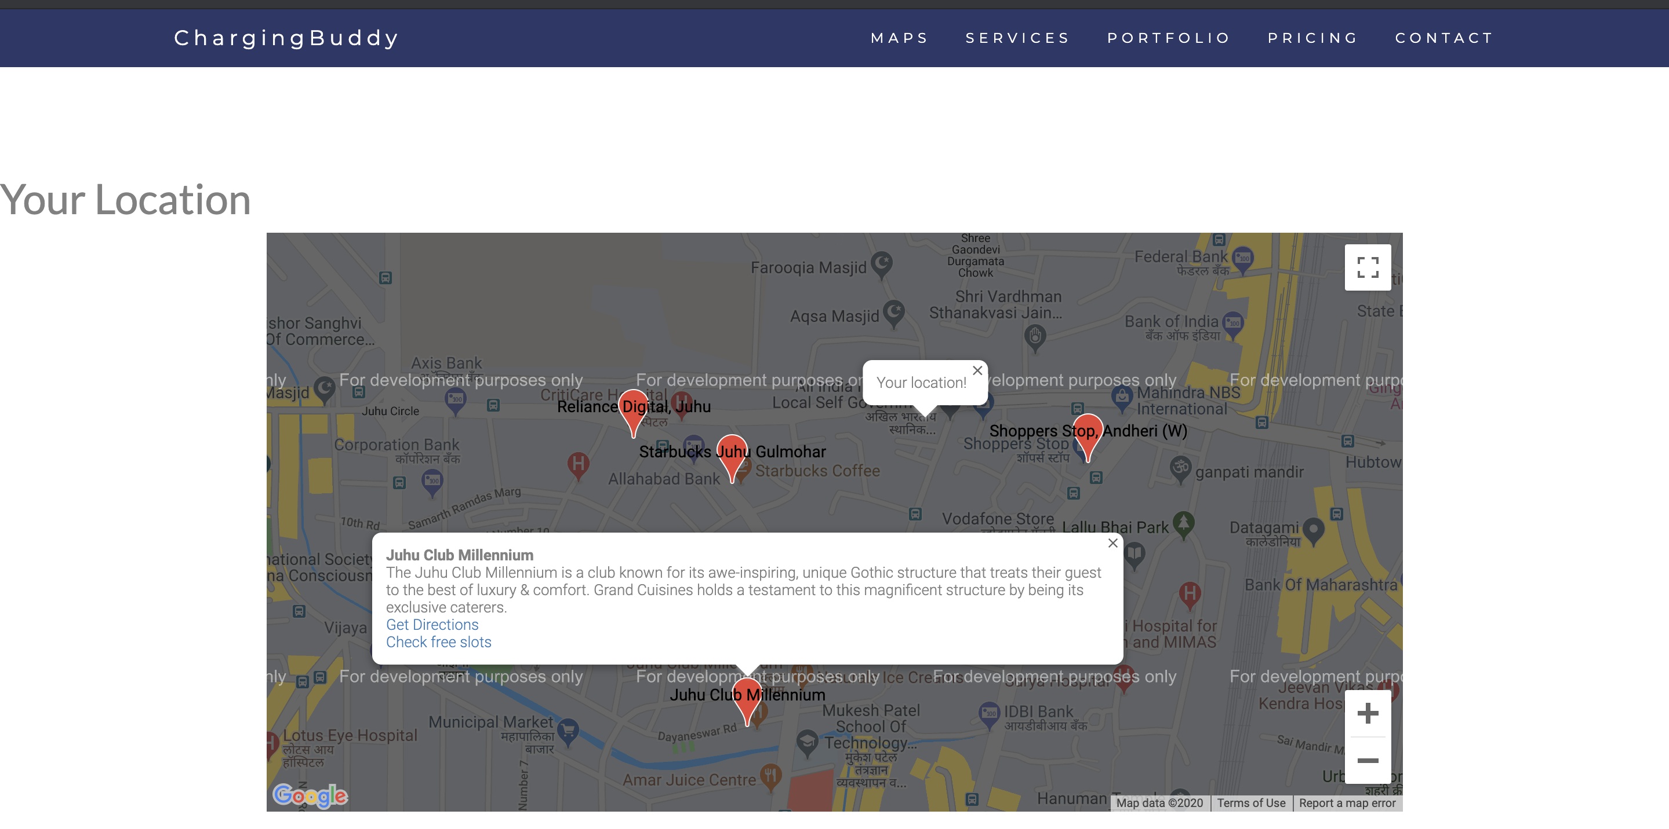
Fig. 1. Map with Charging Stations plotted
This solution not only solve the charging problem of people but also help store owners increase their business. These charging stations would attract more customers and also increase the time that these customers spend in the stores. The charging station login screen would also be used as advertisement real estate that brands would be able to rent to show tailored advertisements. The store owners would also have an option to opt for a personalized advertisement service offered by the platform based on the data collected by user activities.

- Design
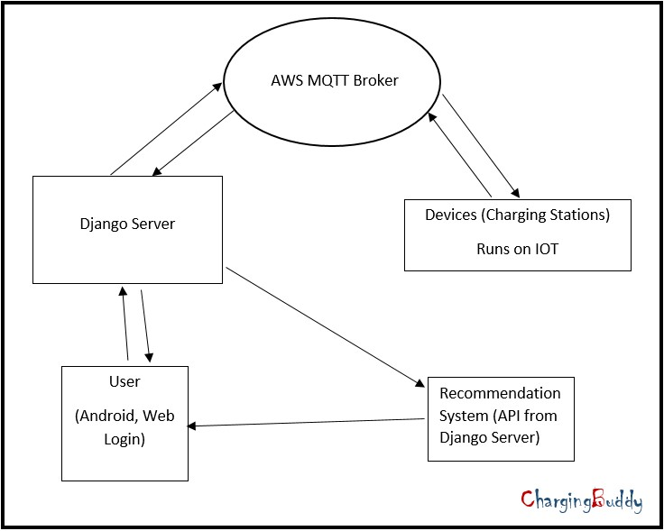
Fig. 2. Proposed System
The proposed solution is divided into two components: a server and an IOT based charging station. The server would be a Django based application hosted on any of the cloud computing platforms like AWS, IBM Cloud, Microsoft Azure, Digital Ocean, etc. The charging stations would be made using the raspberry pi micro-controller. All the details about the charging-station would be updated on the server using the AWS MQTT Broker. The user could browse through these details and when necessary lock/unlock the lockers using the interface on the charging-stations. This interface would be controlled using the raspberry pi controller.
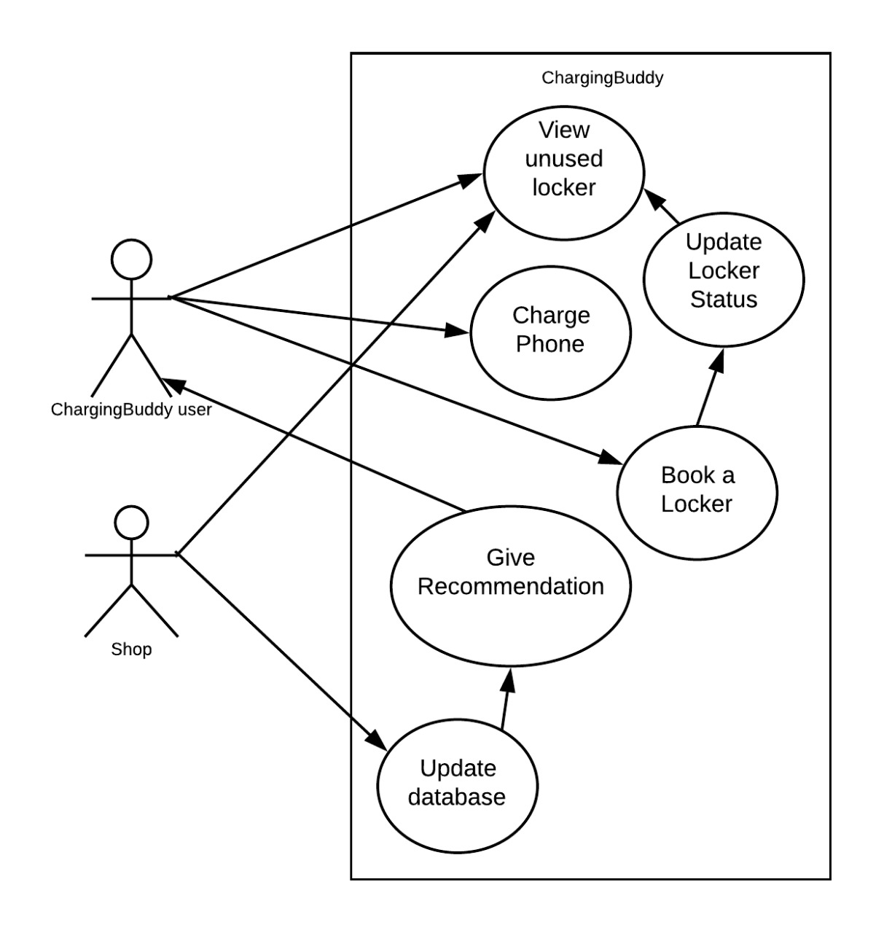
Fig. 3. Use Case Diagram for the proposed system
The user will check for the available lockers in the stations. Accordingly, users can perform the following tasks:
- Use the platform to browse for charging stations across a map.
- Use the platform to navigate to the most convenient charging station.
- Place the device in the Charging station after validation of the request.
- Withdraw the phone from the charging station once finished charging.
- Platform would generate personalized advertisements based on user activity.
- Conclusion
The proposed system was developed taking in mind the benefits of the Users and Shops. In this project, we presented a system which would help users charge their phone and move around without any hesitation. Even in crowded shops and malls where there is a high chance of phone getting stolen. This system will make people worry-free and give them the freedom to wander and buy items around them and hence increasing the shop’s revenue. We achieved this by using a highly secured Django server for User to Server connection and highly secured AWS MQTT for server to station connection. Also, data given by the shops to the system will provide users a shopping recommendation and Offers notifications on the shops they visit. Recommendations are always useful for users as well as shops. This project not only solves the widespread charging problem but also helps the stores increase their sales by drawing in more customers.

References
- M.S.Varadarajan, Veltech Dr.RR, Dr.SR Technical University Chennai, India - Coin Based Universal Mobile Battery Charger IOSR Journal of Engineering (IOSRJEN), ISSN: 2250-3021 Volume 2, Issue 6 (June 2012), PP 1433-1438.
- E. Rammohana Reddy, K. Sankara - Internet of Things Based Home Automation Control System Using Raspberry Pi International Journal of Scientific Research in Computer Science, Engineering and Information Technology, 2018 IJSRCSEIT — Volume 3 — Issue 4 — ISSN: 2456-3307.
- Deepak B. Andore - AWS IOT Platform based Remote Monitoring by using Raspberry P International Journal of Latest Technology in Engineering, Management Applied Science (IJLTEMAS), Volume VI, Issue X, October 2017 — ISSN 2278-2540.
- Nareshkumar R. M., Apoorva Kamat, Dnyaneshvari Shinde - Smart Door Security Control System Using Raspberry Pi,’ proceeding of the International Journal of Innovations Advancement in Computer Science, 6, Issue 11 Novem- ber 2017.
- Prof. B Nithya Ramesh, Aashay R Amballi, Vivekananda Mahanta - DJANGO THE PYTHON WEB FRAMEWORK International Journal of Computer Science and Information Technology Research, Vol. 6, Issue 2, pp: (59-63), Month: April - June 2018.
- Bajorek, Marcin, and Jedrzej Nowak -” The role of a mobile device in a home monitoring healthcare system, Computer Science and Information Systems (Fed- CSIS), 2011 Federated Conference on. IEEE, 2011.
- Tupakula, Udaya, Vijay Varadharajan, and Sunil Kumar Vuppala. - Security Techniques for Beyond 3G Wireless Mobile Networks Embedded and Ubiquitous Computing (EUC), 2011 IFIP 9th International Conference on. IEEE, 2011.
- ” Home Automation as a service”, International Journal of Computer Networks and Wireless Communications (IJCNWC), June 2012.
- S. Nazeem Basha, Dr. S.A.K. Jilani - An Intelligent Door System using Raspberry Pi and Amazon Web Services IoT International Journal of Engineering Trends and Technology (IJETT), vol. 33, pp. 84- 89,2016.
- Rajendra Nayak, Neema Shetty - Secured Smart Home Monitoring System Using Raspberry-PI, International Journal Innovative Research and Development (IJIRD), vol. 5, pp. 339-342,2016.

